CPEG 207 Digital Systems HOMEWORK 8
Name: _______________________________________________
Show your work detail and clearly identify your answer.
- For the circuit shown, complete the timing diagram by showing the Q output (which is initially LOW).
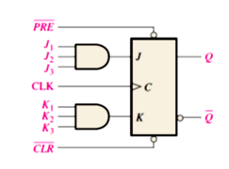 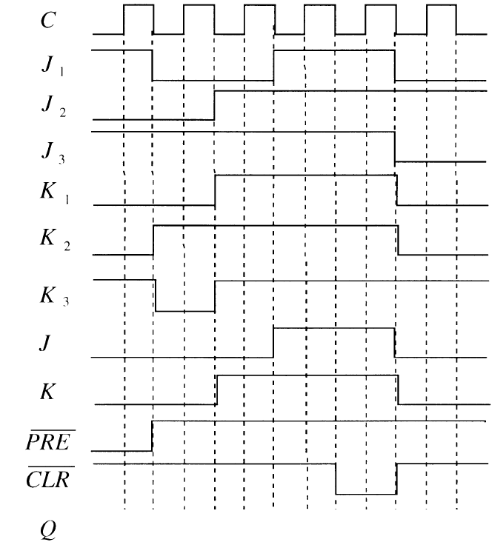
2. For the circuit , determine the maximum frequency of the clock signal for
reliable operation if the set-up time for each flip-flop is 2 ns and the propagation delays (t_{PLH} and t_{PHL}) from clock to output are 5 ns for each flip-flop.
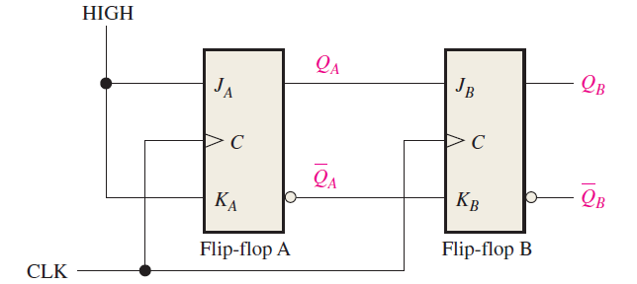

- A) Determine the standard value of the external resistor R₁ in the 555 timer circuit that will produce a 0.5 s output pulse. Choose the capacitor C₁ = 1 µF.
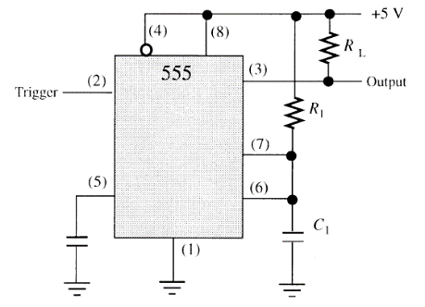
- B) A 555 timer is configured to run as an astable multivibrator as shown.
Determine its frequency.
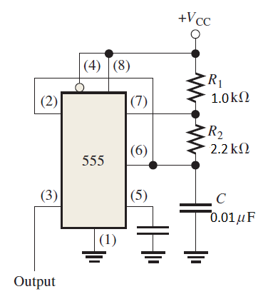

4. Determine if the flip-flop is operating properly, and if not, identify the most probable fault. 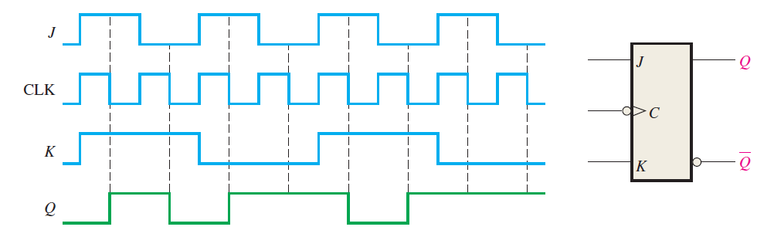
5. Design a basic counting circuit that produces a binary sequence from zero through seven by using negative edge-triggered J-K flip-flops.

